**Improper Integrals, Gamma and Beta Functions**

**Improper Integrals**

An improper integral is an extended concept of a definite integral that has infinite limits on one or both ends of the interval and/or an integrand that becomes infinite at one or more points within the interval of integration (Fig 1). Improper integral is called convergent if the limit of the integral exists with finite value and divergent if the limit of the integral does not exist or has infinite value.

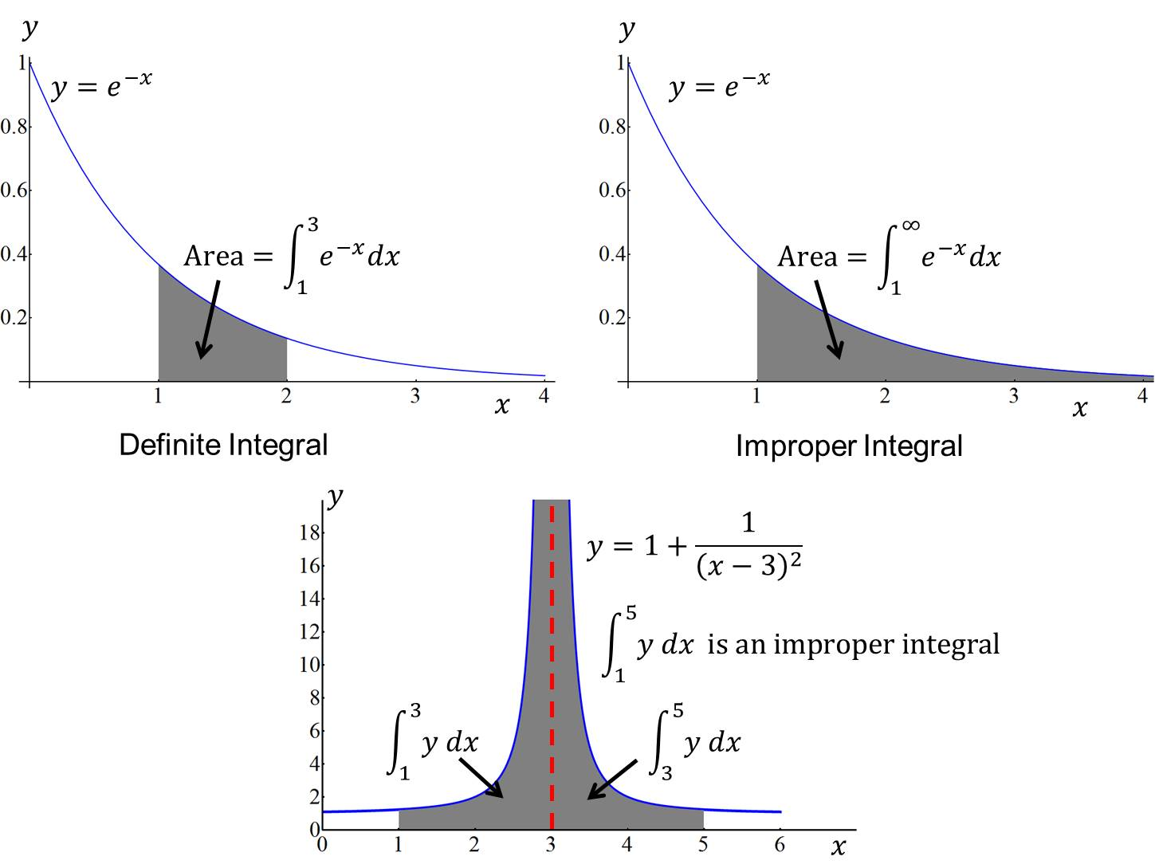

Figure 1: The above figures show the geometrical concept of the definite integral and improper integral.

**Improper integral with infinite limit**

(1) 

(2) 

(3) 



Where *c* is any convenient point.

**Example 1**:



**Example 2**:



Hence the integral diverges.

**Example 3**:











**Improper integral with infinite integrand**

(1) Infinite at : 

(2) Infinite at : 

(3) Infinite at  where :





**Example 4**:



**Example 5**:



Alternatively using substitution

$x=2\sin{θ}⇒dx=2\cos{ θ dθ}$

and $x=0⟹θ=0$ and $x→2^{-}⟹θ={\frac{π}{2}}^{-}$.

Thu $\int_{0}^{2}{\frac{dx}{\sqrt{4-x^{2}}}=\int_{0}^{π/2}{\frac{2\cos{ θ} dθ}{2\cos{ θ}}}}=\int_{0}^{π/2}{ dθ={\left[θ\right]}_{0}^{π/2}}=\frac{π}{2} .$

**Exercise 1**

1. Find, when they exist, the value of the following integrals:

(a) $\int_{1}^{∞}{\frac{1}{x^{2}}} dx$ (b) $\int_{-∞}^{0}{\frac{1}{\sqrt{3-x}}} dx$ (c) $\int_{-∞}^{∞}{xe^{-x^{2}}} dx$

(d) $\int_{0}^{3}{ \frac{1}{\sqrt{3-x}} dx}$ (e) $\int_{0}^{∞}{\frac{1}{1+x^{2}} dx}$ (f) $\int_{0}^{1}{\frac{1}{x^{2}} dx}$

**Answers:** (a) $1$ (b) Divergent (c) $0$ (d) $2√3$ (e) $\frac{π}{2}$ (f) Divergent

**Gamma and Beta Functions**

The Beta function was first studied by Euler and Legendre and was given its name by Jacques Binet. Just as the gamma function for integers describes fac-

torials, the beta function can define a binomial coefficient after adjusting indices. The beta function was the first known scattering amplitude in string theory, first conjectured by Gabriele Veneziano. It also occurs in the theory of the preferential attachment process, a type of stochastic urn process. The incomplete beta function is a generalization of the beta function that replaces the definite integral of the beta function with an indefinite integral. The situation is analogous to the incomplete gamma function being a generalization of the gamma function.

**The Gamma function**

The gamma function  is defined by

,

where, for convergence of the integral, *x*> 0.

Integration by parts gives



, (*x*>0).

By using this recurrence relation when *x* = *n*, *n* being a positive integer ≥ 1, we have



But



and we get the important result



From definition



By substituting , we get 

For evaluation of the integral advanced idea is needed and quoted the result without proof.

**Example 1:**

.

**Example 2:** Consider the integral $\int_{0}^{∞}{\frac{e^{-4x}}{x^{1/2 }}}dx$.

Setting $=4x i.e. x=u/4$, we have $dx=\frac{du}{4}$ and also note that for

$x=0 ⟹ u=0$ and $x→∞⟹ u→∞$.

The integral becomes

$\int_{0}^{∞}{\frac{e^{-4x}}{x^{1/2}}}dx=\int_{0}^{∞}{\frac{2}{u^{1/2}}}e^{-u}\frac{du}{4}=\frac{1}{2}\int_{0}^{∞}{u^{-1/2}e^{-u} du}$

$=\frac{1}{2}Γ\left(\frac{1}{2}\right)=\frac{1}{2}\sqrt{π}$.

**Gamma Function for negative values**

The recurrence relation for positive values of *x* is extended in defining gamma function for negative values of *x*. For $x<0$, the recurrence relation is written as



From the above definition it is clear that it becomes infinity at *x* = 0, and hence  is not defined at all negative values of *x*. It is important to note that  for negative values is not defined by the integral (1).

For example,



**The Beta function**

The beta-function  is defined by the integral



which converges if 

By putting, we have



That is



Thus beta-function is symmetric in *m*, *n*.

An alternative form of the beta-function, obtained from the definition by putting , is

 (2)

**Relation between the Gamma- and Beta-Functions**

The relation between the Gamma- and Beta-Functions may be written as



The proof of the relation need advanced idea and not included here.

Gamma- and Beta-Functions may be used in evaluating integrals.

For example, from eq. (2), we get



**Example 3:** Evaluate the integral $\int_{0}^{2}{\frac{x^{2}}{\sqrt{2x-x^{2}}}} dx$.

The integral can be written as,

$$I=\int_{0}^{2}{\frac{x^{2}}{\sqrt{2x-x^{2}}}} dx=\int_{0}^{2}{\frac{x^{2}}{\sqrt{2x\left(1-x/2\right)}}dx=\frac{1}{\sqrt{2}}\int_{0}^{2}{x^{3/2}}}{(1-\frac{x}{2})}^{-1/2}dx$$

Let $\frac{x}{2}=u$ or $x=2u$ and $dx=2du$.

Also note that

$x=0⟹u=0$ and $x→2^{-}⟹ u→1^{-}$.

The integral becomes,

$$I=\frac{1}{\sqrt{2}}\int_{0}^{1}{{\left(2u\right)}^{\frac{3}{2}}{\left(1-u\right)}^{-\frac{1}{2}} 2 du }$$

$$=4\int_{0}^{1}{u^{\left(\frac{5}{2}-1\right)}{\left(1-u\right)}^{\frac{1}{2}-1}du }$$

$$=4Β\left(\frac{5}{2},\frac{1}{2}\right)=4\frac{Γ\left(\frac{5}{2}\right)Γ\left(\frac{1}{2}\right)}{Γ\left(3\right)}$$

$=4\frac{\left(\frac{3}{2}\right)\left(\frac{1}{2}\right)Γ\left(\frac{1}{2}\right)Γ\left(\frac{1}{2}\right)}{2}=3π/2$.

**Example 4:** Evaluate the integral $\int_{0}^{π/2}{\sin^{5/2}{x\cos^{3}{x dx}}}$.

Using Beta function

$\int_{0}^{π/2}{\sin^{5/2}{x\cos^{3}{x dx=\frac{1}{2}Β\left(\frac{7}{4}, 2\right)=\frac{Γ\left(\frac{7}{4}\right)Γ\left(2\right)}{2Γ\left(\frac{15}{4}\right)}= \frac{Γ\left(\frac{7}{4}\right)×1)}{2(\frac{11}{4})(\frac{7}{4})Γ\left(\frac{7}{4}\right)}=\frac{8}{77}}}}$.

**Exercise 2**

1. Prove that (a)  , (b) ,

(c) , where $n$ is a positive integer .

2. (i) Show that $Β \left(m,n\right)=Β \left(n,m\right)$, (ii) Using definition evaluate.

3. Using the relation , prove that .

4. Evaluate each of the following: (a) (b) , (c) ,

(d) .

5. Evaluate the following:

(a) $\int_{0}^{∞}{x^{4}{ e}^{-x}dx}$ (b) $\int_{0}^{∞}{{√xe}^{-x^{3}}dx}$ (c) $\int_{0}^{∞}{x^{3/2}e^{-x}dx}$

(d) $\int_{0}^{∞}{x^{6}e^{-2x}} dx$ (e) $\int_{0}^{∞}{√y}e^{-y^{2}} dy$ (f) $\int_{0}^{1}{x^{4}{\left(1-x\right)}^{3} dx }$

(g) $\int_{0}^{2}{\frac{x^{2}}{\sqrt{2-x}}} dx$ (h) $\int_{0}^{π/2}{\cos^{6}{θ dθ}}$ (i) $\int_{0}^{π/2}{\sin^{8}{θ dθ}}$

(j) $\int_{0}^{1}{y^{4}\sqrt{1-y^{2} }dy}$ (k) $\int_{0}^{π/2}{\sin^{7}θ{\cos^{5}θ{dθ}}}$

(l) $\int_{-π/2}^{π/2}{\sin^{6}φ\cos^{4}φ }dφ$.

**Answers.**

4. (a) (b) (c) (d) .

5. (a) 24 (b) (c) (d) (e) (f) (g)

(h) (i) (j) $\frac{π}{32}$ (k) $\frac{1}{120}$ (l) $\frac{3π}{256}$.